
SHIRE HIGHLANDS EDUCATION DIVISION
2026 MALAWI SCHOOL CERTIFICATE OF EDUCATION MOCK
EXAMINATION

WOODWORK

PAPER II
Practical
(100 marks)
Wednesday, 11 March Time Allowed: 3 hours sessions
8:00 am onwards

Instructions
1. This paper contains 3 pages. Please check.

2. The maximum number of marks for this paper is 100 marks.

3. Candidates are allowed 10 minutes to read through the paper before starting time.

4. Dimensions not given are left for you to decide.
5. Scrapers, files glue and rasps must NOT be used.
3. Attempt to complete all parts of the test but remember that a partly finished piece of work of high quality may gain more marks than a finished piece of poor quality.
4. At the end of examination, write your NAME clearly on each piece of your work and on the supplied labels. Tie all pieces of work together, including unfinished work, and attach one label to it. Put all your work in one polythene bag and close it. Tie the second label to the closed bag before handing it to the invigilator

You are provided with the following pieces of easily worked hardwood:
1. One pieces 240mm x70mm x 50mm
2. One piece 170mm x 70mm x50mm
3. One piece 260mm x 50mm x50mm
4. One piece 150mm x 30mm x50 mm
From these materials you are required to make a model PART OF A TABLE FRAME shown on page 3

.

NOTES ON THE WORKING PROCEDURE
1. You are advised to mark out and cut all joints before shaping.
2. Cut tenons and dovetails before marking the sockets and mortice.
3. If towards the end of examination, it appears that you are unlikely to finish the test, you should clean up the finished pieces.

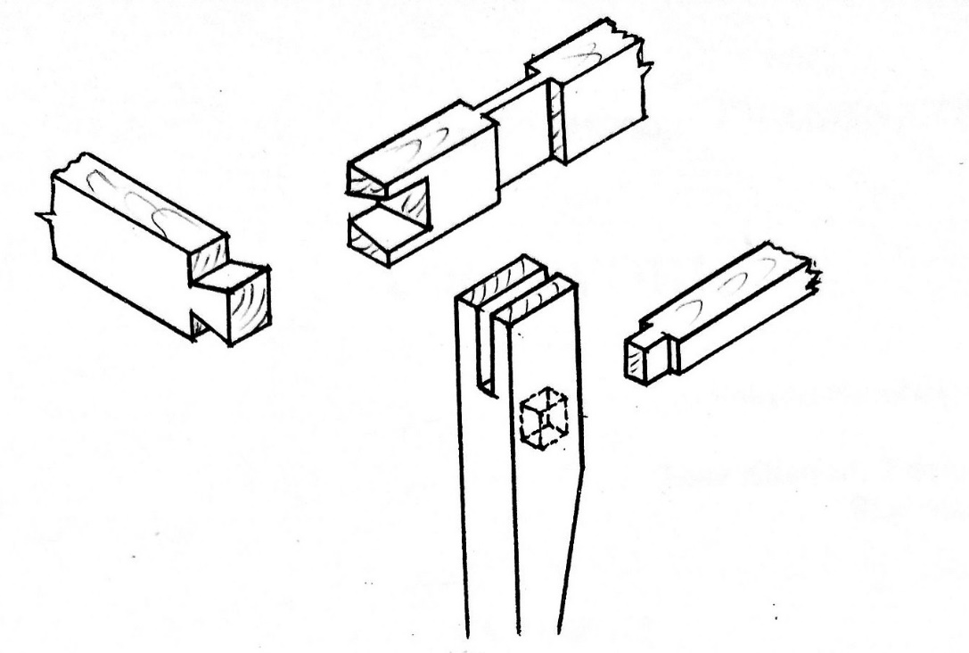
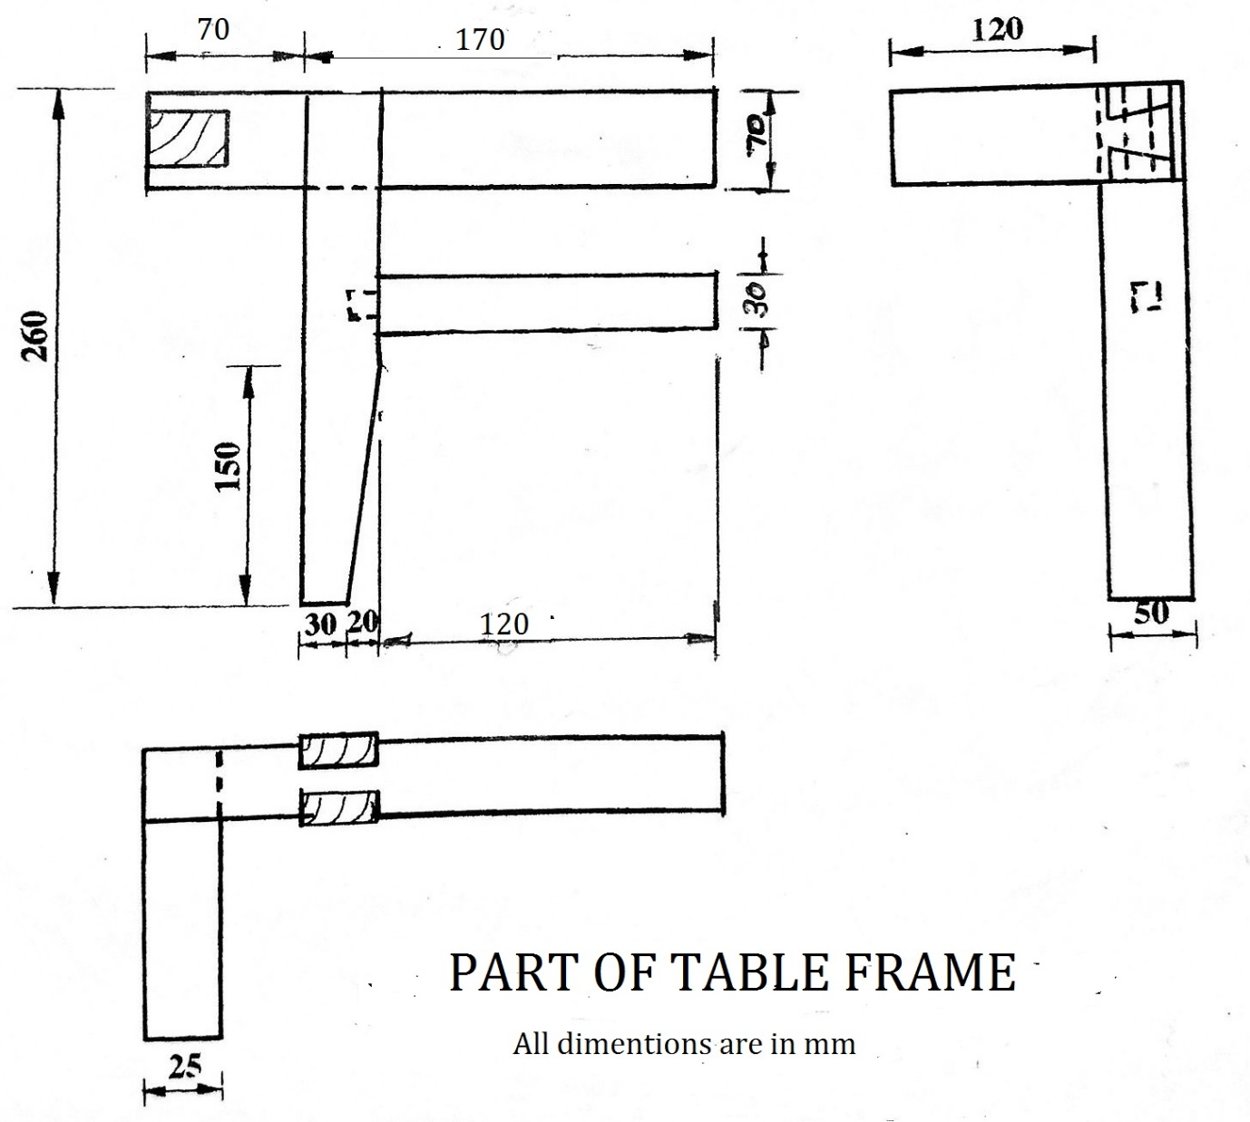
END OF QUESTION PAPER

